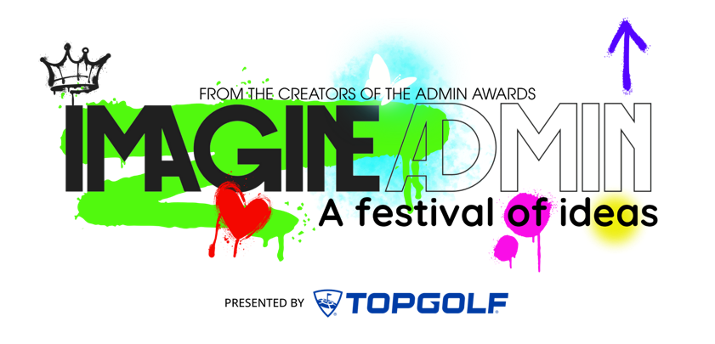

Request for Funds: Imagine Admin – Admin Month Program
Dear [Insert Name],
We’re requesting approval to sponsor our Administrative team for Imagine Admin, an annual national virtual Admin Month experience created by the Admin Awards, the Administrative Profession’s highest honor.
This program combines professional development with celebration, giving our team practical tools they can use immediately while also creating a shared experience that builds connection, energy, and genuine appreciation.
Educational programing for this event is free thanks to the Admin Awards and Topgolf, but there is an opportunity to sponsor which has valuable benefits that our Admin team would appreciate and make this an instant celebration during Admin Month. There are no travel expenses, and all sessions are virtual. If anyone cannot attend live, recordings are available on demand, ensuring full access and flexibility.
Administrative Professionals directly impact executive productivity and day-to-day operations. This program delivers development, recognition, and real application — without travel costs or disruption to schedules.
What Sponsorship Includes:
- National visibility as a supporter of Imagine Admins - and our internal Admin team.
- Access to 30+ educational sessions over three virtual events in April which include practical content on AI, productivity, and strategic partnership - ideas that can be applied immediately to improve workflows and executive support. .
- A structured discussion toolkit and private breakout rooms during the program to help turn our team's learning into action. .
- A built-in Admin Month celebration experience which includes fun, morale-boosting elements including:
Admins Run the World™ high-quality hoodie for each attending Admin
Admins Run the World™ journal for note taking
Official Imagine Admin Discussion Guide
A gift for our executives - it's a surprise ; )
Total Request: $___ (approximately $___ per Admin)
Decision requested by: March 5th
For a modest investment, we can cover Admin Month, strengthen engagement, and elevate the impact of our Admin team in one coordinated initiative.
Thank you for your consideration,

