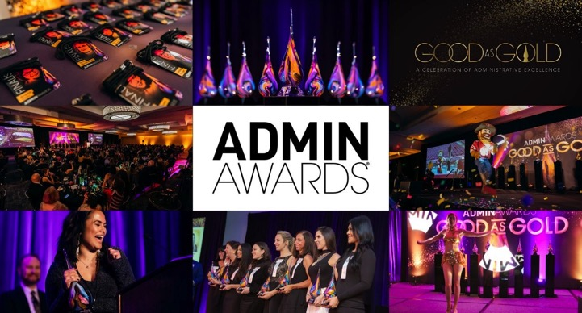

Why Companies Sponsor the Admin Awards

Talking/copy points for Advisory Board Members

There are two broader reasons why companies sponsor the Admin Awards: The Human Resources Reason and the Sales and Marketing Reason. What makes us unique is that it is entirely possible for companies to accomplish both through sponsoring our program!

The Human Resources Reason

The companies that sponsor the Admin Awards send a powerful message to their internal Admin Community that they deeply value their skill, hard work and the integral part they play in their company’s success.

Externally, the visibility they gain through the program positions them as great places to work in a competitive environment. For the Admins who are nominated, become Finalists and go on to win an award, the Admin Awards showcases their achievements to the world by placing them at “center stage” in front of the business community.

The Admin Awards is inclusive. While we are a competition for awards in nine categories, we are at the core a celebration of every Admin who participates in our program. Nominees, Finalists and Admin-participants are treated to a red-carpet experience, with curated gifts and the opportunity to win amazing prizes, valued at a minimum of $500.

For a growing list of companies, including those who have robust internal programs, the Admin Awards is their annual public facing initiative to treat all of their Admins to a special experience designed just for them.

It’s no secret that workplace recognition motivates, provides a sense of accomplishment and makes employees feel valued for their work and dedication. Recognition not only boosts employee engagement, increases productivity and loyalty to the organization, it also leads to higher retention.

- Experts estimate the cost to replace an Administrative Professional is anywhere between 60-80% of that individual’s annual salary.
- According to a workplace study survey by Gallup, employees who do not feel adequately recognized are twice as likely to say they’ll quit in the next year.
- Bonusly's Employee Engagement and Modern Workplace Report revealed that highly engaged employees are 75% less likely to be looking for a job compared to actively disengaged employees.
- A study by Willis Towers Watson revealed that more than 50% of all organizations globally have difficulty retaining some of their most valued employee groups. No doubt, Administrative Professionals would fall in this category.
- One study from the HAAS School of Business at UC Berkeley found that people who feel recognized are 23% more effective and productive, but those who feel like the people around them genuinely care are a whopping 43% more effective.

The Admin Awards has a nine-year history of working closely with Organizations, Executives and Administrative Professionals who unanimously report that recognition through our platform makes these invaluable professionals feel truly cared for and appreciated.

Participation in the Admin Awards not only acts as retention and recruitment tool, it also acts as a company culture builder. Companies truly unite to rally around their Finalists and celebrate the profession. Their efforts often bring them together to interact in a very positive and unique way and share a celebratory experience.

Please Note: The Admin Awards has a strict “church and state” policy related to the competition. An independent Board of Judges determines the competition’s Finalists and Award winners. Sponsoring the Admin Awards does not increase a nominee’s chances of advancing and does not affect the outcome of the competition.

The Sales & Marketing Reason

Since 2012, we’ve earned the trust of the country’s most respected Business Leaders who rely on the Admin Awards to deliver an exceptional recognition experience for their Administrative Support.

This earned trust benefits our Partners tremendously, who quickly realize the Admin Awards difference: our unique ability to not only build awareness with our audience, but more importantly, influence. Influence, coupled with the emotional connections built throughout our program translates into a ten-year history of helping, sales and marketing Partners achieve their most important objectives, often year over year.

The Admin Awards provides multiple avenues to interact with one of the business world’s most elusive audience of decision makers: C-Suite Executives and Administrative Professionals.

The Admin Awards is a highly effective platform for developing the relationships that lead to new business opportunities. With participation in all phases of the program, our Partners gain considerable clout with this coveted audience by interacting with them in an authentic and experiential way.

Through highly customized activations, brand-relevant activities and content marketing, we continually elevate the experience to drive tangible results, with our Partners as our priority.

Our Premier Sponsorships deliver a combination of visibility within the business community, access to our audience, participation in monthly Advisory Board meetings, Admin attendee data (participation in Major Prize program is required), hospitality and the opportunity to present one of nine Admin Awards at the annual Awards Celebration.

Additionally, the Admin Awards is excited to work with organizations who have specific needs on developing customized programs.

